**2021 Drop Tower Challenge**

**DROPLET EJECTION**

<https://www1.grc.nasa.gov/space/education-outreach/drop-tower-competition/>

**WHAT?** Teams of grade 9-12 students are challenged to design and build simple devices using capillary flow (only) to eject water droplets as far as possible while the devices fall down NASA’s [2.2 Second Drop Tower](https://www1.grc.nasa.gov/facilities/drop/).

Teams are only responsible for their capillary devices (e.g., in the microgravity image below), where NASA will provide the rest of the experimental hardware. After developing their concept(s), the youth prepare their proposal, consisting of conceptual drawing(s) and a short entry form, which is e-mailed to [Ed-DropTower@lists.nasa.gov](mailto:Ed-DropTower@lists.nasa.gov).

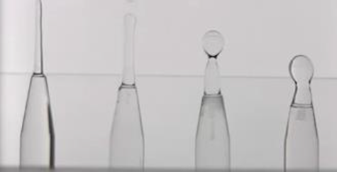If selected, the youth prepare their unique capillary devices based on information provided on the challenge [website](https://www1.grc.nasa.gov/space/education-outreach/drop-tower-competition/). The devices are then sent to NASA where they will fall 24 meters (79 feet) and experience 2.2 seconds of apparent near weightlessness, i.e., microgravity. Video results are provided for student analysis and reporting.

*Example capillary devices*

**WHO?** This design challenge is for students in grades 9-12 from U.S. schools, including the fifty states, District of Columbia, Puerto Rico, American Samoa, Guam, the Northern Mariana Islands, the U.S. Virgin Islands, and all [DODEA](https://www.dodea.edu/) schools (which are for children of U.S. military personnel). With the exception of the DODEA schools, it is not open to participants outside of the United States regardless of citizenship. Teams, which can be of any size, will be favored over individuals in selection. Youth are free to get help from adults, for example in building their experiment hardware. An organization (e.g., school, science center, 4H club, Scout troop) may submit no more than four proposals, where it is envisioned that no more than two will be selected from a single organization. Each student may belong to no more than one team, which may submit no more than one proposal.

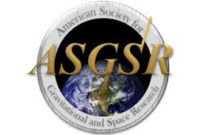**SELECTION?** NASA anticipates selecting up to 20 teams to build objects to be tested at the Glenn Research Center in Cleveland, Ohio. Some preference will be given to teams local (e.g., within 150 miles) to the fall 2021 meeting of the American Society for Gravitational and Space Research ([ASGSR](https://www.asgsr.org/)). However, the conference site has yet to be announced. After evaluation of the experimental results and teams’ reports, a small number of top-performing teams will be invited to present their results in a student poster session at the ASGSR meeting.

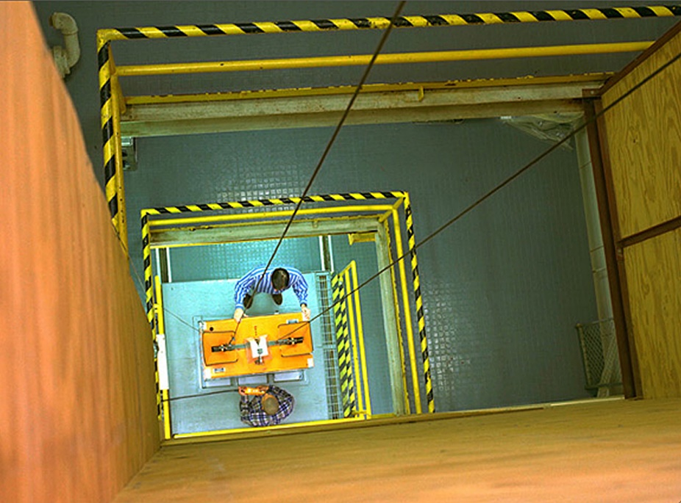**WHERE?** Participation is remote, where participants do not travel to NASA for the testing. An exception is for those teams invited to present their results at the 2021 ASGSR meeting, but the location will not be announced until late 2020.

**COST?** There is no cost to participate in the challenge other than for (1) the preparation of the test objects, (2) the shipment of the test objects to NASA, and (3) travel costs for those invited to present their results at the ASGSR meeting. Regarding the latter, the ASGSR has often provided travel support of $500 each for invited non-local students who present their results at the conference.

*Within the 2.2 Second Drop Tower*

**WHEN?**

Nov. 9, 2020 deadline for proposal

Mid-December NASA announces teams selected for testing

Jan.-Feb. 2021 preparation of test objects

Feb. 15 deadline for arrival of test objects at NASA

Feb.-March testing in NASA’s 2.2 Second Drop Tower

April analysis and report writing

May 3 deadline for written report

Mid-May NASA announces teams selected for ASGSR participation

Fall 2021 annual ASGSR meeting (presumably in Oct. or Nov.)

**WHY?** The odds are very high that your team will be selected for testing. Thus far, 100% of the proposing teams have been selected for participation in this series of problem-based drop tower challenges. Participation in a nation-wide NASA challenge might be good for inclusion on college application,

**HINTS**

* For an introduction to the microgravity ejection of droplets through capillary action, check out this video, [Spontaneous Capillarity-Driven Droplet Ejection](https://www.youtube.com/watch?v=JXKM6D9rPis).
* Conduct your own microgravity trials. For inspiration, check out the [Fire in Free Fall](https://www.pbs.org/video/fire-in-freefall-rare-physics-experiment-eil0iz/) video by Physics Girl [Dianna Cowern](https://physicsgirl.org/about). The challenge staff can provide more additional guidance.
* Design and build a number of test objects so that you can compare and contrast their results in your report … and poster if invited for ASGSR participation.

**QUESTIONS?** Answers can be found at <https://www1.grc.nasa.gov/space/education-outreach/drop-tower-competition/>. If that doesn’t suffice, email the challenge staff at [Ed-DropTower@lists.nasa.gov.](mailto:Ed-DropTower@lists.nasa.gov)